A single component liquid, A, flowing through a shell and tube heat exchanger and is preheated. After the exchanger the hot liquid flows through restriction at which it partly flashes into a vertical cylindrical jacketed vessel. The inside wall of the vessel is coated by a solid catalyst that an endothermic decomposition reaction is taking place as follows.
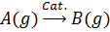
The heat needed for this reaction is prepared from hot oil flowing inside the jacket.
As shown in the following figure, the gas products flow out through a valve to a downstream pressure P₀. The liquid fraction collects in the bottom of the vessel and vaporized by the hot oil flowing through the jacket from the bottom. Note: in each of the following cases draw the information flow diagram.

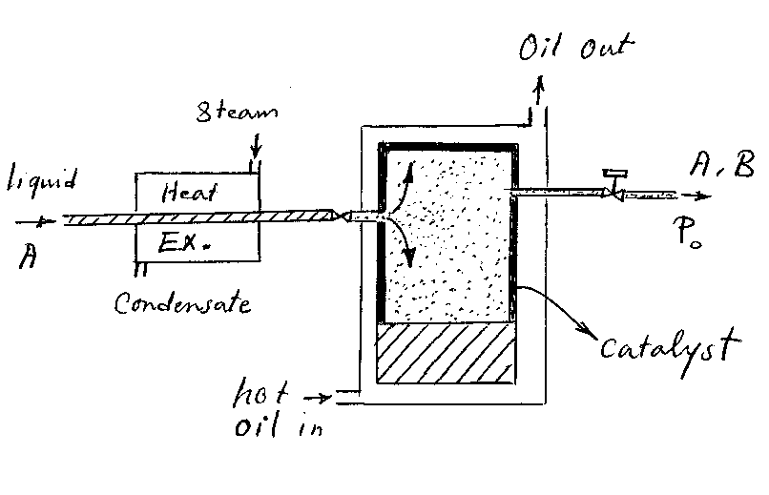

- In the simplest case consider the following assumptions and construct the mathematical model for the whole process.
- A short heat exchanger with very thin tubes and no scaling in the steam side and tube side of it,
- The vessel height is small,
- The reaction is elementary and first order with respect to A reactant,
- The very small amount of liquid is collected in the bottom of the vessel in comparison with the total liquid flow entering the vessel.
- In case 2, an improvement can be carried out on the mathematical model with the following assumptions:
- The heat exchanger is long and there is scaling in the inside wall of the tubes,
- The vessel height is large,
- The experimental work on kinetics of reaction shows that the reaction is contained of the following three stages:
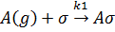
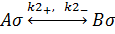
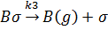
- The small fraction of liquid entering the vessel collected in the vessel bottom.
- Improve the second case in the case that a large amount of liquid collects in the bottom of the vessel.
- If an ejector is used in replace of the valve connecting to the vessel, is the mathematical modeling changed? Construct the modeling in this case.

